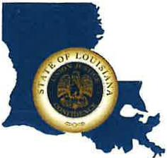 | CAPITAL AREA GROUNDWATER CONSERVATION DISTRICT
GARY I. BEARD
EXECUTIVE DIRECTOR

MEETING NOTICE
Capital Area Groundwater Conservation District Administrative Committee Meeting

WHEN: Friday, April 22, 2022

TIME: 10:00 a.m.

WHERE: LA State Capitol
900 N. 3rd St.
Baton Rouge, LA 70802

Contact Person: Lisa Manda, (225) 293-7370

